**Attendance Management System**

Asaduzzaman Md

2111552104

Net Programming

Chen Laoshi

Nov 8th, 2024

**Attendance Management System**

**Abstract:** 3

**Introduction:** 3

**Main Body:** 4

**Component used for this Application:** 4

**Main Diagram:** 7

**Screenshots Of the Program & Short Description:** 8

**Conclusion:** 31

-

# **Abstract:**

This report explores the development of an automated Attendance Management System designed to simplify employee attendance tracking within an organizational setting. The system provides key functionalities, such as logging, querying, and updating attendance records, with support for multiple attendance statuses like tardiness, early departures, absences, and full attendance. Built as a Windows Forms application, the system offers a user-friendly interface, enabling users to search records by employee ID, name, or specific attendance status. By digitizing attendance record-keeping, this system improves data accuracy and accessibility while minimizing errors common in manual methods. The project employs a systematic approach, encompassing requirements analysis, design, coding, and testing, to deliver a reliable solution that addresses attendance management challenges.

# **Introduction:**

In today’s competitive business environment, effective attendance management is a critical factor in organizational success. This paper explores the complexities of optimizing attendance management systems through a structured, data-driven approach.

1. **Research Question:** How can attendance management be optimized using a structured and secure application?
2. **Justification (Significance):** Accurate attendance tracking is essential for managing employee productivity, determining payroll, and maintaining organizational accountability. Manual tracking systems are prone to errors, time-consuming, and challenging to update. By providing a streamlined, automated solution, this Attendance Management System reduces the administrative burden on HR staff, minimizes errors, and allows quick and efficient access to attendance records.
3. **Background and Literature Review:** Effective attendance management is crucial for monitoring employee productivity and accurately calculating payroll in most organizations. Traditional methods, such as paper-based records or spreadsheets, often lack the efficiency and precision needed in today’s fast-paced work environments. While existing attendance management systems offer some level of automation, they frequently fall short in addressing specific needs, such as tracking multiple attendance statuses (e.g., tardiness, absenteeism) and ensuring secure modification options. This project overcomes these challenges by introducing a Windows Forms application that supports various attendance statuses, secure data modification, and an intuitive search interface.
4. **Sources of Data and Methodology:** Sample employee records were created for testing the system. These records included employee IDs, names, check-in and check-out times, and status indicators for tardiness, early departure, absenteeism, and full attendance.
5. **Methodology:**

• **Form-Based Interface Design**: The application was built using Windows Forms, which offers a user-friendly interface to streamline navigation and data entry.

• **Data Handling**: Each attendance record includes fields such as Employee ID, name, and attendance statuses. The system allows records to be retrieved through flexible search criteria, meeting HR needs for fast access to specific attendance details.

1. **Organization of the Paper**: The paper is organized as follows: Firstly, we will examine the challenges faced by organizations in managing employee attendance. Next, we will review relevant literature on automated approaches to attendance management. Following this, we will outline the methodology used in this study. Finally, we will present our findings, discuss their implications, and offer recommendations for future research and practical applications. Through this structure, we aim to provide a thorough understanding of the benefits and potential of automated systems in optimizing attendance management in organizations.

# **Main Body:**

## **Component used for this Application:**

1. Visual Studio

2. C#

3. .Net SDK

4. MySQL

5. Windows Form App

**Visual Studio:** Visual Studio is a powerful integrated development environment (IDE) created by Microsoft, designed to streamline software development across various platforms and technologies. Serving as a comprehensive toolkit for developers, Visual Studio offers a wide range of features and tools to support the entire software development lifecycle, from coding and debugging to testing and deployment.

At its core, Visual Studio provides a user-friendly interface that enables developers to write, edit, and debug code efficiently. With support for multiple programming languages such as C#, C++, JavaScript, and Python, it caters to a diverse community of developers working on different types of projects.

One of Visual Studio's standout features is its extensive ecosystem of extensions and integrations, allowing developers to customize their development environment and enhance productivity with additional tools and functionalities.

Moreover, Visual Studio offers seamless integration with other Microsoft services and platforms, including Azure cloud services, GitHub repositories, and Azure DevOps, facilitating collaborative development and deployment workflows.

In essence, Visual Studio empowers developers to build high-quality software solutions faster and more effectively, making it a preferred choice for professionals and teams worldwide.

**C#:** C# (pronounced "C sharp") is a modern, versatile programming language developed by Microsoft as part of its .NET framework. With its roots in the C and C++ programming languages, C# combines the power of low-level programming with the simplicity of high-level syntax, making it an ideal choice for building a wide range of applications.

C# is renowned for its robustness, type-safety, and object-oriented programming features, allowing developers to create scalable, maintainable, and efficient software solutions. Its rich set of libraries and frameworks provide comprehensive support for tasks ranging from desktop and web application development to game development and beyond.

Key features of C# include automatic memory management through garbage collection, strong typing for enhanced code reliability, and extensive support for modern programming paradigms such as asynchronous programming and functional programming.

Moreover, C# is continuously evolving with updates and enhancements introduced regularly by Microsoft, ensuring that developers have access to cutting-edge tools and technologies to stay ahead in the rapidly evolving software development landscape.

**.Net SDK:** The .NET Software Development Kit (SDK) is a comprehensive set of tools, libraries, and resources provided by Microsoft for building applications on the .NET platform. It serves as the primary toolkit for developers looking to create a wide range of software solutions, including web applications, desktop applications, mobile apps, and cloud-based services.

At its core, the .NET SDK includes the .NET runtime, which provides the necessary environment for executing .NET applications, along with a suite of libraries and frameworks that enable developers to write code efficiently and effectively. These libraries encompass a wide range of functionalities, from basic data structures and algorithms to advanced features for web development, database access, and more.

One of the key strengths of the .NET SDK is its versatility and cross-platform compatibility. With support for multiple operating systems, including Windows, macOS, and Linux, developers can build applications that run seamlessly across diverse environments without compromising performance or functionality.

Furthermore, the .NET SDK integrates seamlessly with popular development tools and services, such as Visual Studio, Visual Studio Code, and Azure DevOps, enabling developers to leverage familiar workflows and collaborate effectively with their teams.

**Windows Form App:** A Windows Forms application, often abbreviated as WinForms, is a type of graphical user interface (GUI) application framework developed by Microsoft for building desktop applications on the Windows operating system. It provides developers with a set of pre-built controls and components that can be easily dragged and dropped onto a design surface, allowing for rapid development of Windows-based applications.

Windows Forms applications are typically developed using the .NET framework and programming languages such as C# or Visual Basic.NET. These applications follow a traditional event-driven programming model, where user interactions and system events trigger responses from the application through event handlers.

One of the key advantages of Windows Forms applications is their familiarity and ease of use for developers familiar with the Windows platform. The drag-and-drop interface of Visual Studio, Microsoft's integrated development environment (IDE), makes it straightforward to design user interfaces and connect them to underlying code logic.

Windows Forms applications support a wide range of features and functionalities, including customizable user interfaces, data binding capabilities, support for multimedia elements, and integration with other Windows-based technologies such as COM components and Windows API functions.

* **Section 2**: System Requirements and Analysis – covers the functional and non-functional requirements of the system.
* **Section 3**: System Design and Architecture – describes the design decisions and form layouts in detail.
* **Section 4**: Implementation and Testing – provides an overview of core functionalities and the testing process.
* **Section 5**: Conclusion – summarizes findings, highlights the system's value, and suggests potential future improvements.

## **Main Diagram:**

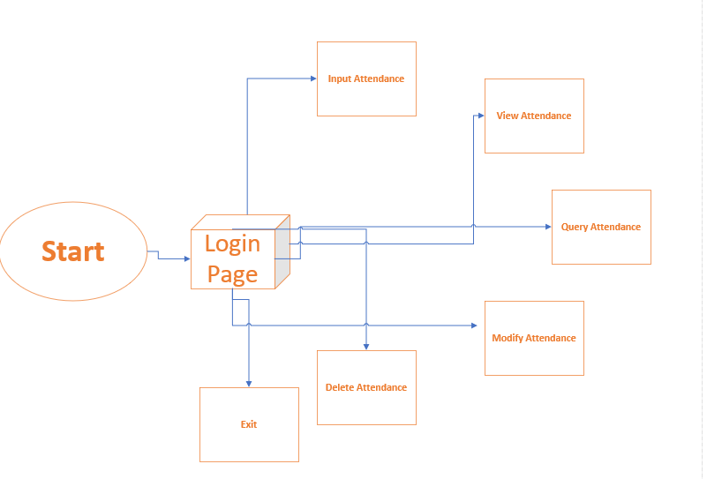

## **Screenshots Of the Program & Short Description:**

**Login page: Loginto the Attendance Management System using username & password**

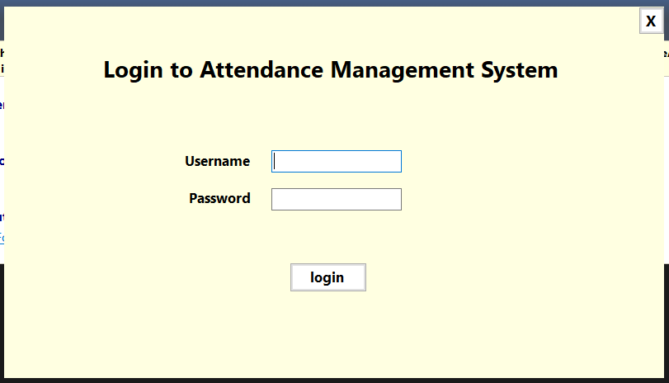

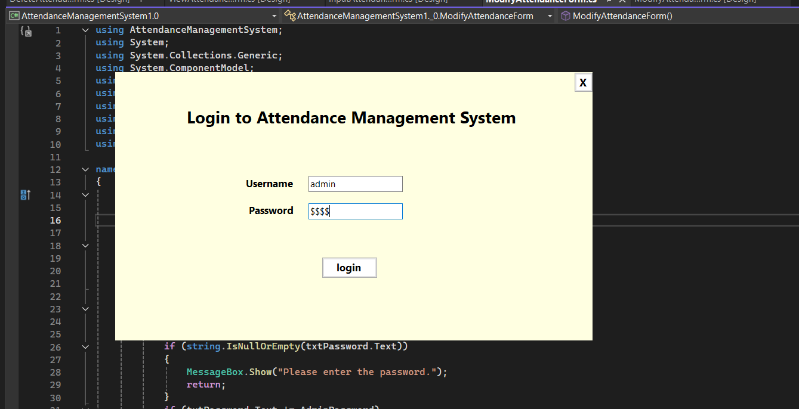

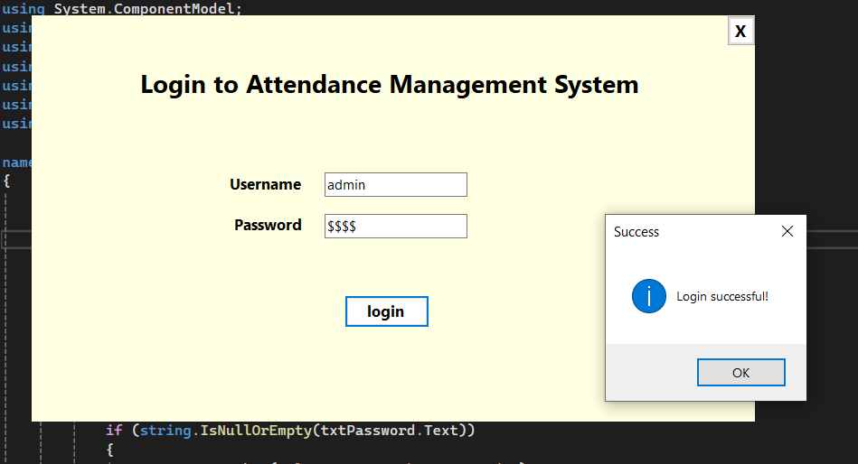

**Login Page Code:**

**namespace AttendanceManagementSystem1._0**

**{**

**public partial class Form1 : Form**

**{**

**public Form1()**

**{**

**InitializeComponent();**

**}**

**private void button1_Click(object sender, EventArgs e)**

**{**

**// Replace these with actual validation checks or database calls**

**string username = "admin"; // Example username**

**string password = "0000"; // Example password**

**if (textBox1.Text == username && textBox2.Text == password)**

**{**

**// Successful login**

**MessageBox.Show("Login successful!", "Success", MessageBoxButtons.OK, MessageBoxIcon.Information);**

**// Open the MainForm and close the login form**

**Mainform mainForm = new Mainform();**

**mainForm.Show();**

**this.Hide();**

**}**

**else**

**{**

**// Invalid login**

**MessageBox.Show("Invalid username or password.", "Login Failed", MessageBoxButtons.OK, MessageBoxIcon.Error);**

**textBox2.Clear();**

**textBox1.Focus();**

**}**

**}**

**private void button2_Click(object sender, EventArgs e)**

**{**

**Application.Exit();**

**}**

**}**

**}**

**MainForm :** In the main form here included 6 form with the buttons. Here the exit button is using for exit the whole system, work as a logout.

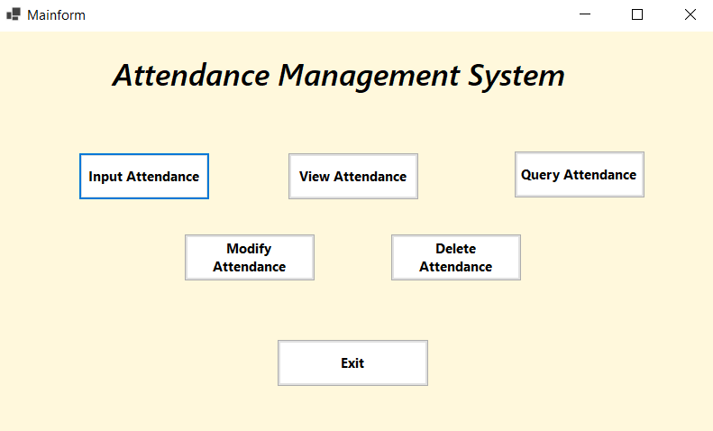

**Input Attendance :** Here need to input employee id & employee name. CheckIn Button & CheckOut Button work as a employee checkin and checkout status.

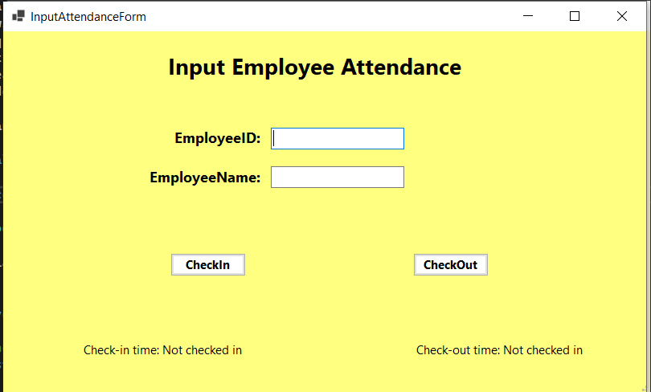

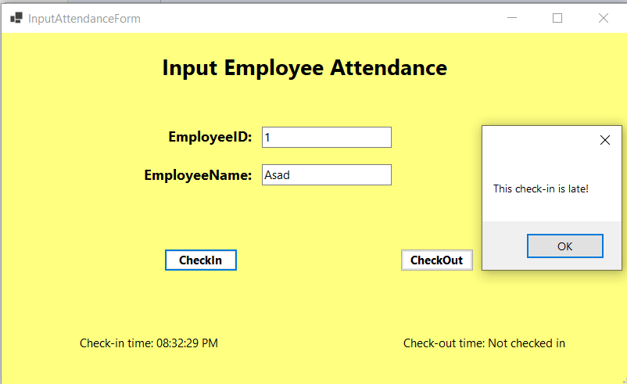

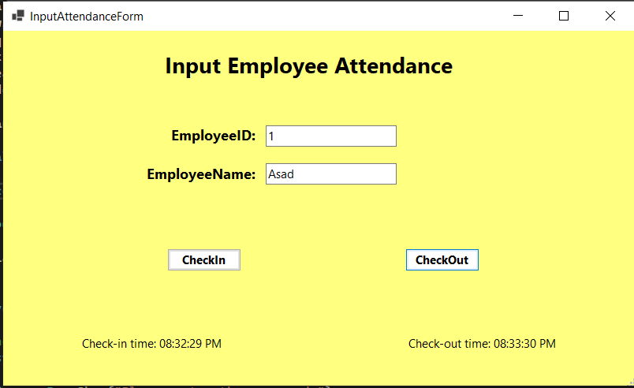

**Input Attendance Form Code:**

**namespace AttendanceManagementSystem1._0**

**{**

**public partial class InputAttendanceForm : Form**

**{**

**public InputAttendanceForm()**

**{**

**InitializeComponent();**

**}**

**private int GetSelectedEmployeeID()**

**{**

**if (int.TryParse(textBox1.Text, out int employeeID))**

**return employeeID;**

**MessageBox.Show("Please enter a valid Employee ID.");**

**return -1;**

**}**

**private void btnCheckIn_Click(object sender, EventArgs e)**

**{**

**int employeeID = GetSelectedEmployeeID();**

**var employee = EmployeeData.Employees.FirstOrDefault(emp => emp.EmployeeID == employeeID);**

**if (employee != null)**

**{**

**employee.CheckIn(DateTime.Now);**

**lblCheckInTime.Text = "Check-in time: " + employee.CheckInTime?.ToString("hh:mm:ss tt");**

**if (employee.Tardiness == 1)**

**{**

**MessageBox.Show("This check-in is late!");**

**}**

**}**

**else**

**{**

**MessageBox.Show("Employee not found!");**

**}**

**}**

**private void btnCheckOut_Click(object sender, EventArgs e)**

**{**

**int employeeID = GetSelectedEmployeeID();**

**var employee = EmployeeData.Employees.FirstOrDefault(emp => emp.EmployeeID == employeeID);**

**if (employee != null)**

**{**

**employee.CheckOut();**

**lblCheckOutTime.Text = "Check-out time: " + employee.CheckOutTime?.ToString("hh:mm:ss tt");**

**if (employee.EarlyDepartures == 1)**

**{**

**MessageBox.Show("This check-out is early!");**

**}**

**}**

**else**

**{**

**MessageBox.Show("Employee not found!");**

**}**

**}**

**}**

**}**

**View Attendance:** In this form we can see every employee status in datagridview.

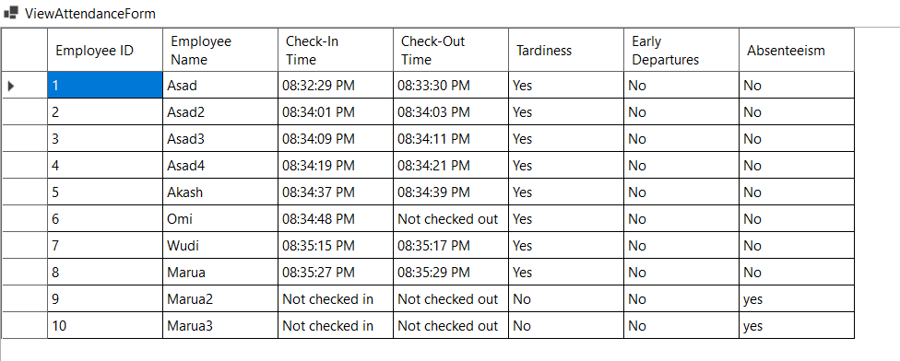

**View Attendance Form Code:**

**namespace AttendanceManagementSystem1._0**

**{**

**public partial class ViewAttendanceForm : Form**

**{**

**public ViewAttendanceForm()**

**{**

**InitializeComponent();**

**InitializeDataGridView();**

**// Check absenteeism status before loading records**

**EmployeeData.EndOfDayCheck();**

**LoadAttendanceRecords();**

**}**

**private void InitializeDataGridView()**

**{**

**// Set up DataGridView layout and appearance**

**dgvAttendanceRecords.AutoGenerateColumns = false;**

**dgvAttendanceRecords.Columns.Clear();**

**// Manually add columns**

**dgvAttendanceRecords.Columns.Add(new DataGridViewTextBoxColumn**

**{**

**HeaderText = "Employee ID",**

**DataPropertyName = "EmployeeID",**

**Name = "EmployeeIDColumn"**

**});**

**dgvAttendanceRecords.Columns.Add(new DataGridViewTextBoxColumn**

**{**

**HeaderText = "Employee Name",**

**DataPropertyName = "EmployeeName",**

**Name = "EmployeeNameColumn"**

**});**

**dgvAttendanceRecords.Columns.Add(new DataGridViewTextBoxColumn**

**{**

**HeaderText = "Check-In Time",**

**DataPropertyName = "CheckIn",**

**Name = "CheckInTimeColumn"**

**});**

**dgvAttendanceRecords.Columns.Add(new DataGridViewTextBoxColumn**

**{**

**HeaderText = "Check-Out Time",**

**DataPropertyName = "CheckOut",**

**Name = "CheckOutTimeColumn"**

**});**

**dgvAttendanceRecords.Columns.Add(new DataGridViewTextBoxColumn**

**{**

**HeaderText = "Tardiness",**

**DataPropertyName = "Tardiness",**

**Name = "TardinessColumn"**

**});**

**dgvAttendanceRecords.Columns.Add(new DataGridViewTextBoxColumn**

**{**

**HeaderText = "Early Departures",**

**DataPropertyName = "EarlyDepartures",**

**Name = "EarlyDeparturesColumn"**

**});**

**dgvAttendanceRecords.Columns.Add(new DataGridViewTextBoxColumn**

**{**

**HeaderText = "Absenteeism",**

**DataPropertyName = "Absenteeism",**

**Name = "AbsenteeismColumn"**

**});**

**// Set dock style to fill the form**

**dgvAttendanceRecords.Dock = DockStyle.Fill;**

**// Optional: Set a nicer appearance (border, header style, etc.)**

**dgvAttendanceRecords.BorderStyle = BorderStyle.Fixed3D;**

**dgvAttendanceRecords.ColumnHeadersHeightSizeMode = DataGridViewColumnHeadersHeightSizeMode.AutoSize;**

**// Add padding around the DataGridView**

**dgvAttendanceRecords.Margin = new Padding(10);**

**}**

**private void ViewAttendanceForm_Load(object sender, EventArgs e)**

**{**

**// Create a layout panel for organizing the form**

**var panel = new TableLayoutPanel**

**{**

**Dock = DockStyle.Fill,**

**ColumnCount = 1,**

**RowCount = 2,**

**Padding = new Padding(10),**

**AutoSize = true**

**};**

**}**

**private void LoadAttendanceRecords()**

**{**

**var attendanceRecords = EmployeeData.Employees**

**.Select(emp => new**

**{**

**EmployeeID = emp.EmployeeID,**

**EmployeeName = emp.EmployeeName,**

**CheckIn = emp.CheckInTime.HasValue ? emp.CheckInTime.Value.ToString("hh:mm:ss tt") : "Not checked in",**

**CheckOut = emp.CheckOutTime.HasValue ? emp.CheckOutTime.Value.ToString("hh:mm:ss tt") : "Not checked out",**

**Tardiness = emp.Tardiness == 1 ? "Yes" : "No",**

**EarlyDepartures = emp.EarlyDepartures == 1 ? "Yes" : "No",**

**Absenteeism = emp.Absenteeism == 1 ? "yes" : "No"**

**})**

**.ToList();**

**dgvAttendanceRecords.DataSource = attendanceRecords;**

**}**

**}**

**}**

**Query Attendance:** Here we can search every employee status by their employee id.

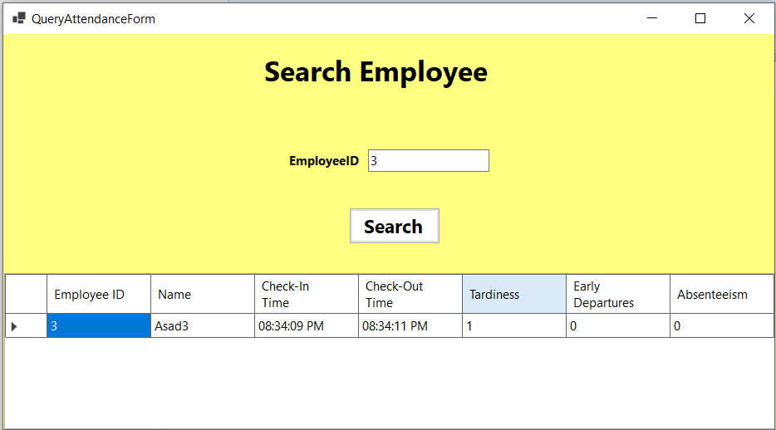

**Query Code:**

**namespace AttendanceManagementSystem1._0**

**{**

**public partial class QueryAttendanceForm : Form**

**{**

**public QueryAttendanceForm()**

**{**

**InitializeComponent();**

**InitializeDataGridView();**

**}**

**private void InitializeDataGridView()**

**{**

**dgvSearchResults.AutoGenerateColumns = false;**

**dgvSearchResults.Columns.Clear();**

**// Employee ID column**

**dgvSearchResults.Columns.Add(new DataGridViewTextBoxColumn**

**{**

**HeaderText = "Employee ID",**

**DataPropertyName = "EmployeeID", // Matches the EmployeeID property in Employee class**

**Name = "EmployeeIDColumn"**

**});**

**// Name column**

**dgvSearchResults.Columns.Add(new DataGridViewTextBoxColumn**

**{**

**HeaderText = "Name",**

**DataPropertyName = "EmployeeName", // Ensure this matches the Employee class property for name**

**Name = "NameColumn"**

**});**

**// Check-In Time column**

**dgvSearchResults.Columns.Add(new DataGridViewTextBoxColumn**

**{**

**HeaderText = "Check-In Time",**

**DataPropertyName = "CheckIn", // Using formatted CheckIn in the query results**

**Name = "CheckInTimeColumn"**

**});**

**// Check-Out Time column**

**dgvSearchResults.Columns.Add(new DataGridViewTextBoxColumn**

**{**

**HeaderText = "Check-Out Time",**

**DataPropertyName = "CheckOut", // Using formatted CheckOut in the query results**

**Name = "CheckOutTimeColumn"**

**});**

**// Tardiness column**

**dgvSearchResults.Columns.Add(new DataGridViewTextBoxColumn**

**{**

**HeaderText = "Tardiness",**

**DataPropertyName = "Tardiness", // Ensure this matches the Employee class property for tardiness**

**Name = "TardinessColumn"**

**});**

**// Early Departures column**

**dgvSearchResults.Columns.Add(new DataGridViewTextBoxColumn**

**{**

**HeaderText = "Early Departures",**

**DataPropertyName = "EarlyDepartures", // Ensure this matches the Employee class property for early departures**

**Name = "EarlyDepartureColumn"**

**});**

**// Absenteeism column**

**dgvSearchResults.Columns.Add(new DataGridViewTextBoxColumn**

**{**

**HeaderText = "Absenteeism",**

**DataPropertyName = "Absenteeism", // Ensure this matches the Employee class property for absenteeism**

**Name = "AbsenteeismColumn"**

**});**

**// Optional: Customize appearance**

**dgvSearchResults.BorderStyle = BorderStyle.Fixed3D;**

**dgvSearchResults.ColumnHeadersHeightSizeMode = DataGridViewColumnHeadersHeightSizeMode.AutoSize;**

**}**

**private void btnSearch_Click(object sender, EventArgs e)**

**{**

**// Retrieve input from TextBoxes**

**string employeeId = txtEmployeeID.Text.Trim();**

**// Perform search based on Employee ID**

**var filteredRecords = EmployeeData.Employees**

**.Where(emp =>**

**(string.IsNullOrEmpty(employeeId) || emp.EmployeeID.ToString() == employeeId)**

**)**

**.Select(emp => new**

**{**

**emp.EmployeeID,**

**EmployeeName = emp.EmployeeName,**

**CheckIn = emp.CheckInTime?.ToString("hh:mm:ss tt") ?? "Not checked in",**

**CheckOut = emp.CheckOutTime?.ToString("hh:mm:ss tt") ?? "Not checked out",**

**emp.Tardiness,**

**emp.EarlyDepartures,**

**emp.Absenteeism**

**})**

**.ToList();**

**// Display results in DataGridView**

**if (filteredRecords.Any())**

**{**

**dgvSearchResults.DataSource = filteredRecords;**

**}**

**else**

**{**

**MessageBox.Show("No records match the search criteria.", "Search Results", MessageBoxButtons.OK, MessageBoxIcon.Information);**

**dgvSearchResults.DataSource = null; // Clear grid if no results**

**}**

**}**

**}**

**}**

**Modify Attendance:** We can modify every employee status after input password.

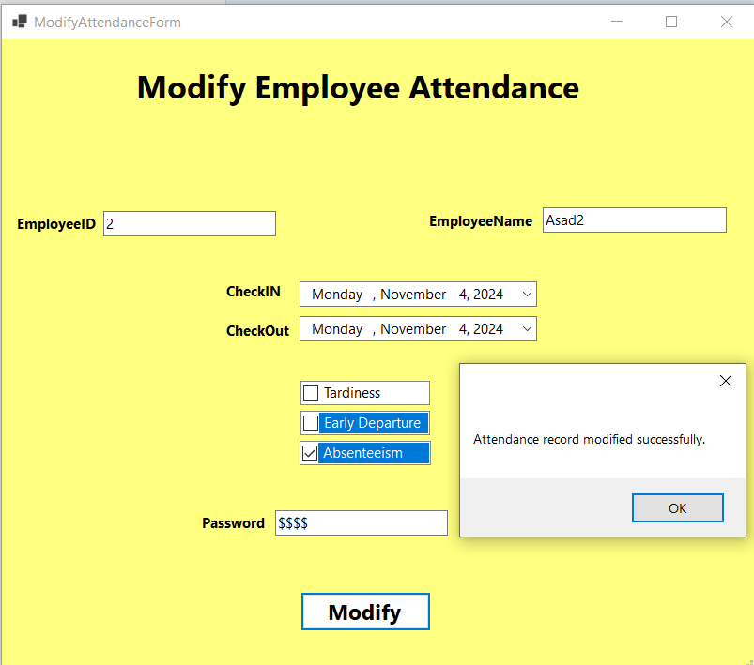

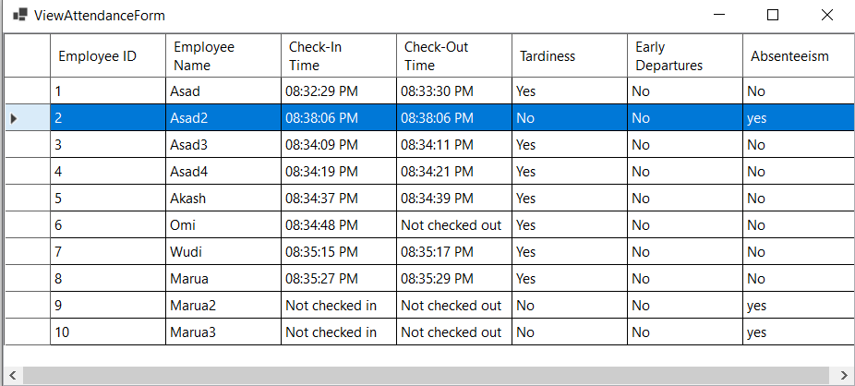

**Modify Code:**

**namespace AttendanceManagementSystem1._0**

**{**

**public partial class ModifyAttendanceForm : Form**

**{**

**private const string AdminPassword = "0000"; // Set admin password here**

**public ModifyAttendanceForm()**

**{**

**InitializeComponent();**

**}**

**private void btnModify_Click(object sender, EventArgs e)**

**{**

**// Check if password is empty**

**if (string.IsNullOrEmpty(txtPassword.Text))**

**{**

**MessageBox.Show("Please enter the password.");**

**return;**

**}**

**if (txtPassword.Text != AdminPassword)**

**{**

**MessageBox.Show("Incorrect password.");**

**return;**

**}**

**var employee = EmployeeData.Employees**

**.FirstOrDefault(emp =>**

**emp.EmployeeID.ToString() == txtEmployeeID.Text &&**

**emp.EmployeeName == txtEmployeeName.Text);**

**if (employee == null)**

**{**

**MessageBox.Show("Employee record not found.");**

**return;**

**}**

**// Update fields based on user input**

**employee.CheckInTime = dtpCheckInTime.Value;**

**employee.CheckOutTime = dtpCheckOutTime.Value;**

**// Update Tardiness and Early Departures based on checkbox states**

**employee.Tardiness = chkTardiness.CheckedItems.Contains("Tardiness") ? 1 : 0;**

**employee.EarlyDepartures = chkEarlyDeparture.CheckedItems.Contains("Early Departure") ? 1 : 0;**

**// Handle Absenteeism**

**if (chkAbsenteeism.CheckedItems.Contains("Absenteeism"))**

**{**

**// Mark as Absent if Absenteeism checkbox is checked**

**employee.SetAbsenteeism(1);**

**}**

**else**

**{**

**// If unchecked, mark as Present (ensure both Check-In and Check-Out are set)**

**if (employee.CheckInTime.HasValue && employee.CheckOutTime.HasValue)**

**{**

**employee.SetAbsenteeism(0); // Present**

**}**

**else**

**{**

**MessageBox.Show("Please provide both Check-In and Check-Out times to mark as Present.");**

**return;**

**}**

**}**

**MessageBox.Show("Attendance record modified successfully.");**

**}**

**}**

**}**

**Delete Attendance:** IN this section we can delete any employee with their status.

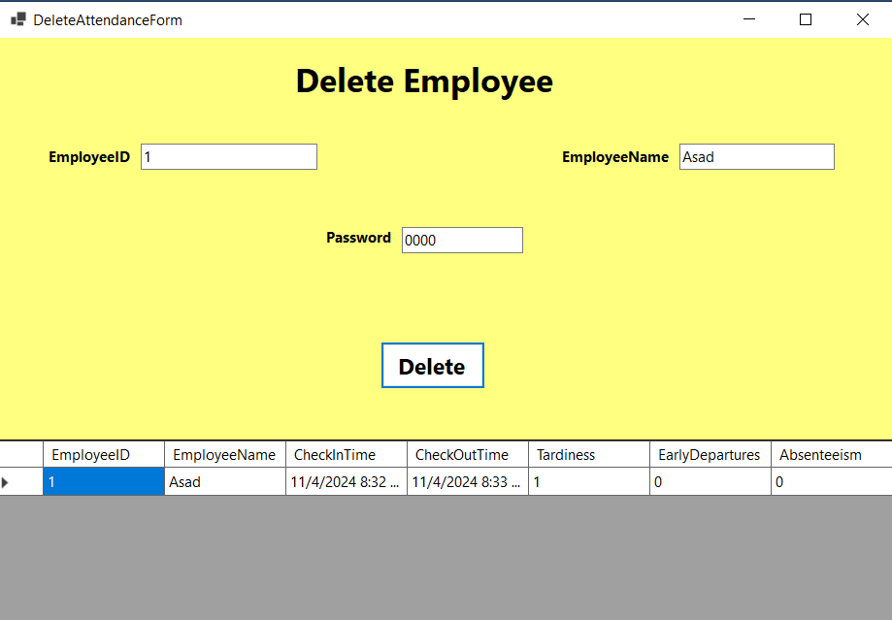

**Delete Code:**

**namespace AttendanceManagementSystem1._0**

**{**

**public partial class DeleteAttendanceForm : Form**

**{**

**private const string AdminPassword = "0000"; // Set your admin password here**

**public DeleteAttendanceForm()**

**{**

**InitializeComponent();**

**}**

**private void btnDelete_Click(object sender, EventArgs e)**

**{**

**// Check if password is empty**

**if (string.IsNullOrEmpty(txtPassword.Text))**

**{**

**MessageBox.Show("Please enter the password.");**

**return;**

**}**

**if (txtPassword.Text != AdminPassword)**

**{**

**MessageBox.Show("Incorrect password.");**

**return;**

**}**

**var employee = EmployeeData.Employees**

**.FirstOrDefault(emp =>**

**(string.IsNullOrEmpty(txtEmployeeID.Text) || emp.EmployeeID.ToString() == txtEmployeeID.Text) &&**

**(string.IsNullOrEmpty(txtEmployeeName.Text) || emp.EmployeeName == txtEmployeeName.Text));**

**if (employee == null)**

**{**

**MessageBox.Show("Employee record not found.");**

**return;**

**}**

**EmployeeData.Employees.Remove(employee);**

**dgvDeleteConfirmation.DataSource = new[] { employee };**

**MessageBox.Show("Attendance record deleted successfully.");**

**}**

**}**

**}**

# **Conclusion:**

In conclusion, this paper has explored the complexities of developing an automated Attendance Management System, highlighting the potential for streamlined processes and increased accuracy in tracking employee attendance. Through a detailed examination of relevant literature and methodologies, key findings have emerged regarding the impact of automation on attendance management.

**Recapitulation of Main Findings:** This study has emphasized the importance of an automated system in efficiently managing employee attendance data, reducing errors, and simplifying HR processes. By implementing automated tracking and record-keeping, organizations can enhance data accuracy, improve accessibility, and support more efficient attendance management.

**Statements about Values or Alternative Insights:** Beyond the operational advantages, adopting an automated Attendance Management System signifies a shift toward more reliable and secure record management. By leveraging technology, organizations can gain clearer insights into employee attendance patterns, productivity, and compliance, contributing to a more organized and accountable workplace.

**Indications of Relevance to Current Circumstances or Future Possibilities:** As businesses increasingly prioritize efficiency, data accuracy, and streamlined processes, the relevance of automated attendance management systems has become essential. Looking forward, the potential for further enhancements in this field is significant, with advancements in biometric integration, mobile accessibility, and real-time data analytics promising even more sophisticated and adaptable attendance solutions.

In conclusion, the implementation of an automated Attendance Management System offers substantial benefits for enhancing organizational efficiency, ensuring data integrity, and supporting HR decision-making. As organizations continue to adapt to the demands of the modern workplace, embracing automation in attendance tracking will be crucial for maintaining productivity, accountability, and sustainability in the years ahead.